Chapter 4, Problem 43.

Find the Thevenin equivalent looking into terminals a-b of the circuit in Fig. 4.110 and solve for i_{x}.

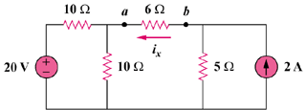

Figure 4.110
For Prob. 4.43.

